3d 2 Your Favorite Childhood Story Name_____________________
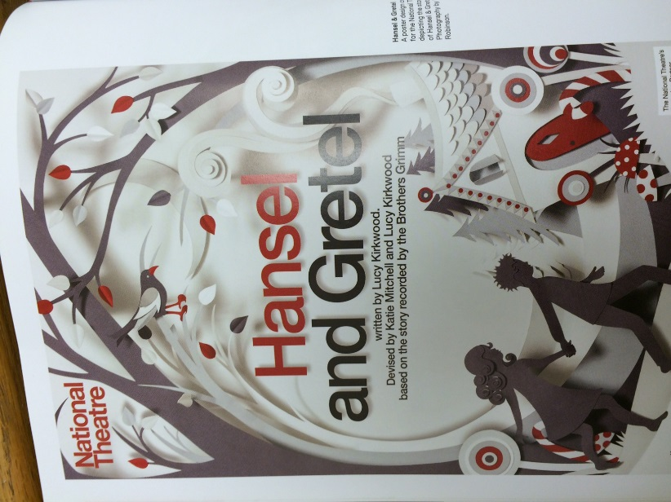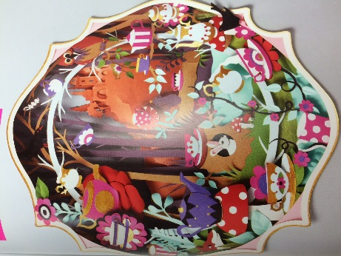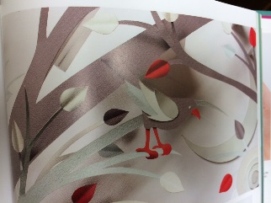
Learning target: SWBAT create their own childhood story using paper, exacto knives and cutting different layers.
The Task: You will write/type a brief outline of your story to go along with your project. You need at least 4 different layers making sure to cut exactly. The size needs to be at least 8.5 x 11 inches. You need to pick one art element (line, value, texture, space, form, color, shape) and at least one design principle (variety, emphasis, balance, symmetry/asymmetry, contrast, proportion, rhythm or repetition) to address in your composition.
Grading:
Criteria | Excellent | Good | Average | Needs Work | Student total | Teacher total
At least 5 different values have been layered | 4 | 3 | 2 | 1
Different heights added by spacers to achieve a 3d look have neatly been added (hidden) | 4 | 3 | 2 | 1
Craftsmanship: strong composition, careful attention to cutting the layers  When it starts to tear, get a new exacto blade | 4 | 3 | 2 | 1
Work ethic/professionalism: | Work ethic/professionalism: Positive attitude, worked every day, always on task, did not complain about the assignment, on time, and took the assignment further, challenged yourself and showed a high dedication to learning and improvement, asking questions when necessary and using all information sources available, including your classmates.  Cell phones not out | Good attitude, worked every day, mostly on task and used material correctly. The student showed a dedication to learning and improvement and usually asked questions when necessary. Did not complain, cell phone not out other than music time. | Attitude could use some help, student was often off task and used materials and tools incorrectly. The student showed very limited dedication to learning and improvement. The student rarely asked questions and disrupted others, moving about the room and talking loudly. | Attitude was poor. Lack of effort, commitment or participation during the work time which includes disrespect, inappropriate language, misuse with tools in a wasteful or dangerous way, moving throughout the room, disrupting others, excessively talking over the teacher, excessive tardies, complaining…WHINING!
Clean up: cleaned up after yourself | 4 | 3 | 2 | 1
Story is typed up and goes along with the cut out | 20 |  |  | 0
Composition: is strong, fills 80% of the picture plane | 4 | 3 | 2 | 1
Total points 44 |  |  |  |  | Student total | Teacher total

- How does an artists’ choice of tools affect the product? What if you did the same thing using a different material?

- What story did you pick to portray and why?

- What art element did you select and what design principle did you use and why?

