3d Art 2 Wire Skulls
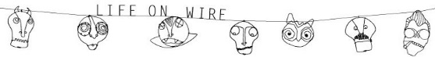

Learning Target: SWBAT create 5 different skulls using wire and string. We will be hanging these up in our Dia de los Muertos by next Wednesday.
The Task: After designing your five skulls and learning about Dia de los Muertos, you will design 5 different skulls and use wire and string to hang them up (Wednesday is the day).
Grading:
Criteria | Excellent | Good | Average | Needs work | Student total | Teacher total
Craftsmanship: Skulls are put together well and attached to the string securely | 4 | 3 | 2 | 1
Creativity: Designs are your own and unique | 4 | 3 | 2 | 1
Work ethic: worked bell to bell, no cell phones out, no games, no texting, Instagram, etc. | 4 | 3 | 2 | 1
Clean up: cleaned up after yourself and others | 4 | 3 | 2 | 1
Sketches: sketches are planned out in your sketchbook | 3 or more sketches | 2 sketches | 1 sketch | No planning or sketches
Total points 20 |  |  |  |  | Student total | Teacher total

- What did you learn about Dias de los Muertos that was new to you?

