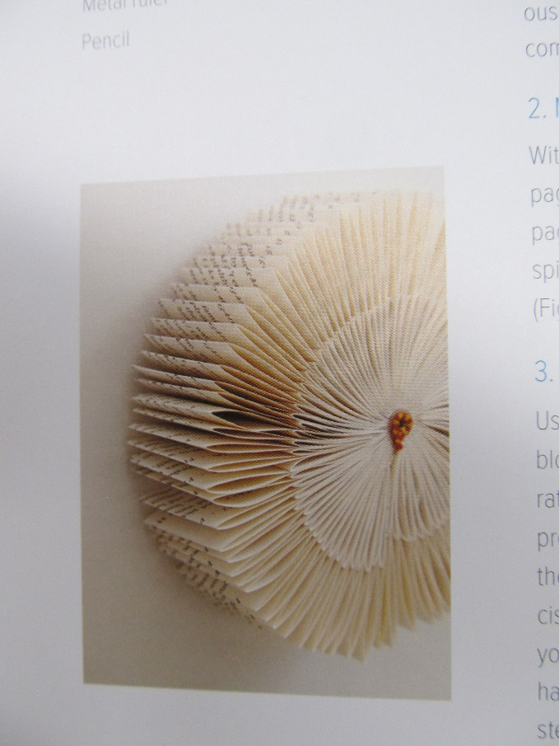
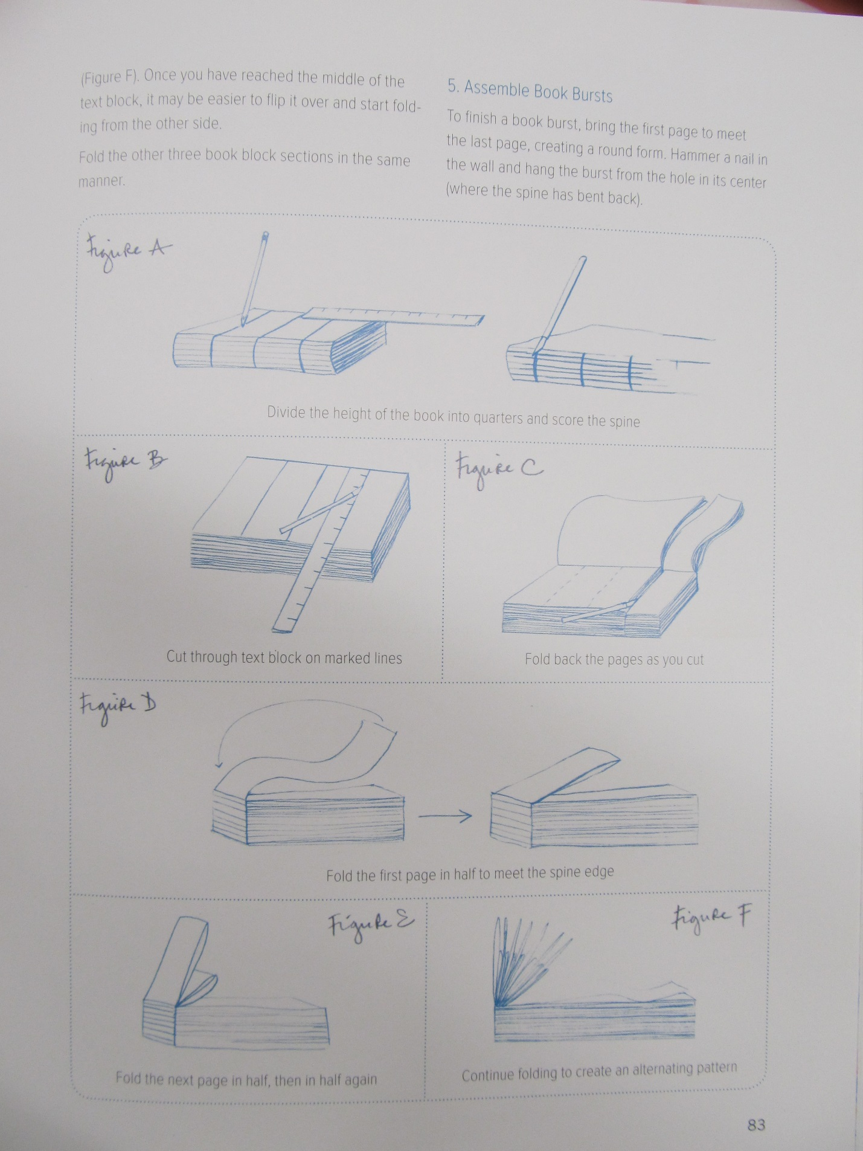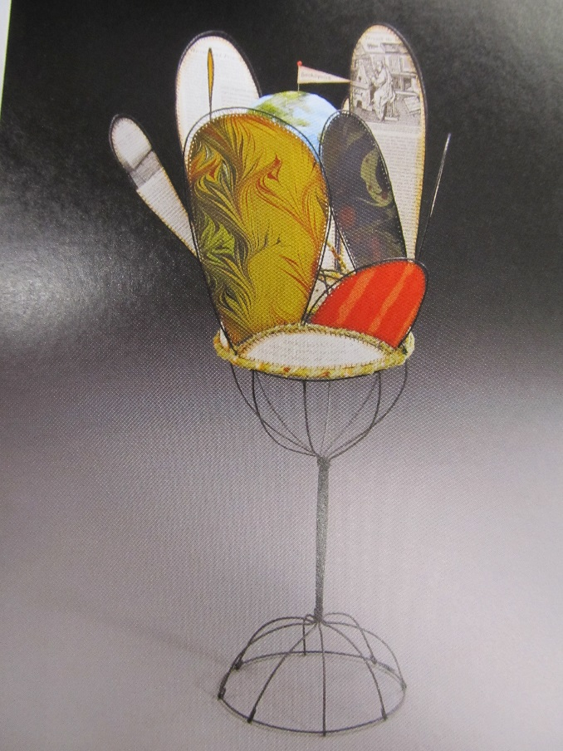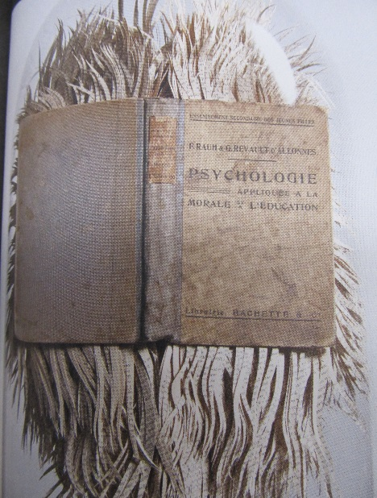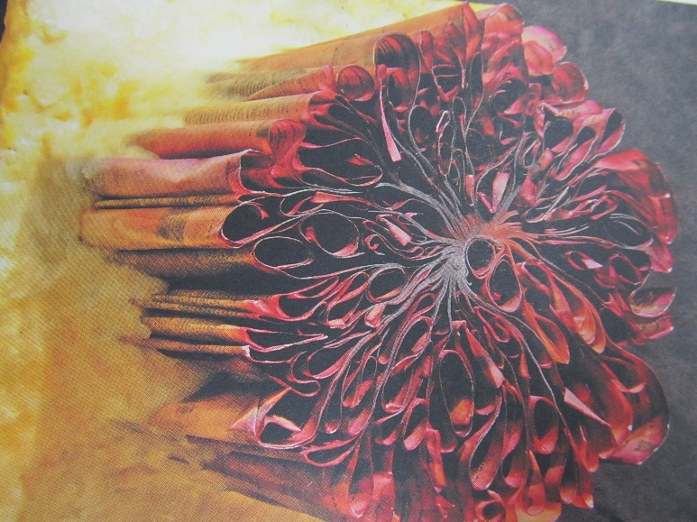
First, you will deconstruct your book, making a book burst.
You will divide your book into either 3 sections or 4 sections. Each section will be a different style of book arts, with the first as the book burst.
There are several different options available to you and the skies the limit for your creativity. They do need to hang together as a grouping or be installed together.
You can use the cover, you can cut strips, etc.
Deconstructing a book

Grading:
Criteria | Excellent | Good | Average | Needs Work | Student total | Teacher total
Book burst created | 4 | 3 | 2 | 1
Craftsmanship of all 3 sections of books, cut straight if intention was straight, curved, etc | 4 | 3 | 2 | 1
Creativity of the 3 different book arts, they are part of a whole, installed together | 4 | 3 | 2 | 1
Work ethic/professionalism: | Work ethic/professionalism: Positive attitude, worked every day, always on task, did not complain about the assignment, on time, and took the assignment further, challenged yourself and showed a high dedication to learning and improvement, asking questions when necessary and using all information sources available, including your classmates.  Cell phones not out | Good attitude, worked every day, mostly on task and used material correctly. The student showed a dedication to learning and improvement and usually asked questions when necessary. Did not complain, cell phone not out other than music time. | Attitude could use some help, student was often off task and used materials and tools incorrectly. The student showed very limited dedication to learning and improvement. The student rarely asked questions and disrupted others, moving about the room and talking loudly. | Attitude was poor. Lack of effort, commitment or participation during the work time which includes disrespect, inappropriate language, misuse with tools in a wasteful or dangerous way, moving throughout the room, disrupting others, excessively talking over the teacher, excessive tardies, complaining…WHINING!
Clean up: cleaned up after yourself | 4 | 3 | 2 | 1
Total points 20 |  |  |  |  | Student total | Teacher total

- How does an artists’ choice of tools affect the product? What if you did the same thing using a different material?

- What worked well for you and what would you do differently next time?

