Mat board construction: SWBAT construct a sculpture using mat board and cutting to fit pieces. You have one day to construct and take photos of it, including shadows.

Grading: Shows movement and variety, great craftsmanship, and balance-either symmetrical or asymmetrical.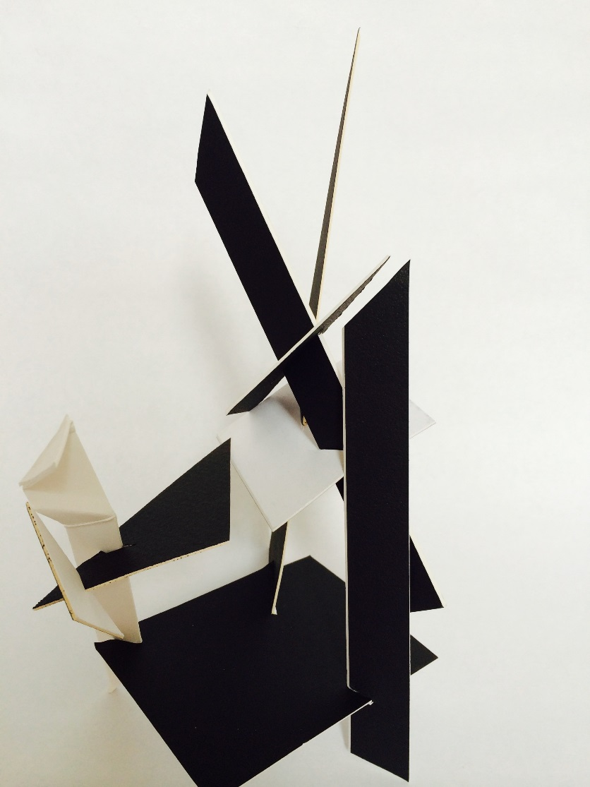 You will need to take photos for your file (AP & 3d 4).

|  |  |  |  |  |  |  |
| --- | --- | --- | --- | --- | --- | --- |
| Criteria | Excellent (4) | Good (3) | Average (2) | Needs work (1) | Student total | Teacher total |
| Deadline met for matboard sculpture (should be one day for mat board, one day for taking away part of it and then adding zip ties for the next day, worked to full potential every day |  |  |  |  |  |  |
| Sketches and planning | Sketched 3 or more designs | Sketched 2 designs | Sketched 1 design | Little planning-no sketches |  |  |
| Clean up & care for tools: Cleaned up after yourself, wiped tables clean, put tools away |  |  |  |  |  |  |
| Creativity: Unique-shows movement, asymetrical or symmetrical balance  Did you ask your neighbor for advice? |  |  |  |  |  |  |
| Craftsmanship: Mat board is put together well. Use slits and insert them together. |  |  |  |  |  |  |
| Photos have been taken and put into your file in your U drive and you used the rolled up graduated gray background, flashlights from cells to create shadows |  |  |  |  |  |  |
|  |  |  |  |  |  |  |
| Total points 24 |  |  |  |  | Student total | Teacher total |