Name____________________________3d art working with reed and tissue paper

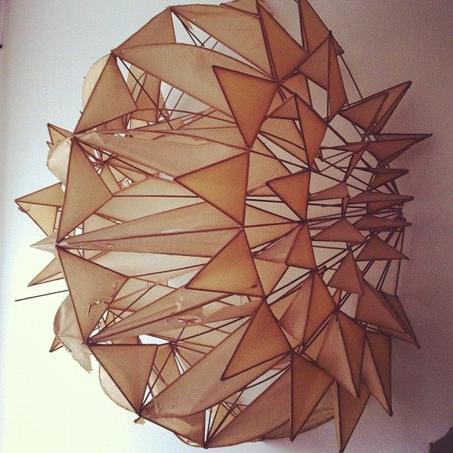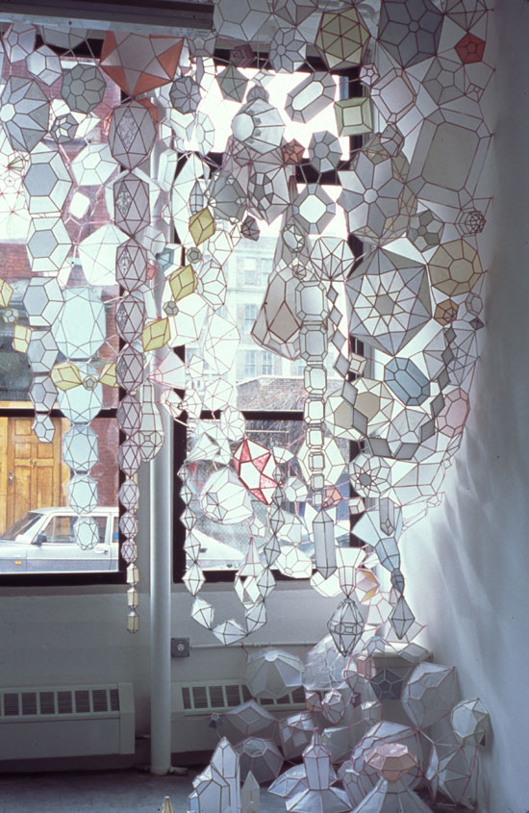 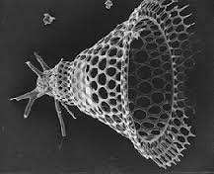Radiolaria

Learning Target: SWBAT create a 3d sculpture at least 18 inches tall by 12 inches tall, working on the basis of looking at Art Forms in Nature. Your work will be based on natural forms, it could be cellular, skeletal, nature based, mineral (crystals, skeletal structure of a mineral).
You will be focusing on design, repetition, balance, and color theory.

***NOTE: your piece must be based on natural forms.
Criteria | Excellent (4) | Good (3) | Average (2) | Needs work (1) | Student total | Teacher total
Deadline met, worked to full potential every day
Sketches and planning | Sketched 3 or more designs | Sketched 2 designs | Sketched 1 design | Little planning-no sketches
Clean up & care for tools: Cleaned up after yourself, wiped tables clean, put tools away

Creativity: Unique, individual designs-care given to fine details of using reed and tissue paper
Craftsmanship: Tissue paper is glued in place, glue is not spilling out, edges are seamed (demo) and finished. Everything looks whole/complete.

Work ethic/professionalism: | Positive attitude, worked every day, always on task, did not complain about the assignment, on time, and took the assignment further, challenged yourself and showed a high dedication to learning and improvement, asking questions when necessary and using all information sources available, including your classmates.  Cell phones not out | Good attitude, worked every day, mostly on task and used material correctly. The student showed a dedication to learning and improvement and usually asked questions when necessary. Did not complain, cell phone not out other than music time. | Attitude could use some help, student was often off task and used materials and tools incorrectly. The student showed very limited dedication to learning and improvement. The student rarely asked questions and disrupted others, moving about the room and talking loudly. | Attitude was poor. Lack of effort, commitment or participation during the work time which includes disrespect, inappropriate language, misuse with tools in a wasteful or dangerous way, moving throughout the room, disrupting others, excessively talking over the teacher, excessive tardies, complaining…WHINING!
Color theory, balance and repetition are evident
Is a natural form found in nature
Total points 32 |  |  |  |  | Student total | Teacher total

What form did you decide to do and why?

What was difficult?

What was easy?

