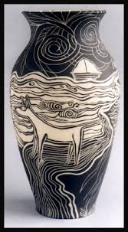
Name__________________________Day __________per____________
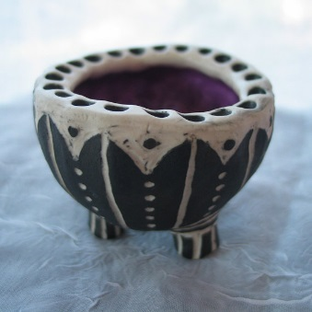 Pinch pot bowls
The task: SWBAT create 2 pinch pots that are perfect after watching the video from Karanspotsandglass, where she goes over specific techniques to smooth the clay body and make the pinch pot. One pinch pot will be glazed using scraffito (underglaze while the pinch pot is leather hard and carve in with a design to make the clay body). You can use the zentangle designs or come up with your own design or look on the website: Tanglepatterns.com, focusing on repetition.
You will make 2 pinch pots, 1 will be for our Pop Up Art Gallery and will be for sale. Proceeds will be given to the Oregon Food Bank.
Criteria | Excellent (4) | Good (3) | Average (2) | Needs work (1) | Student total | Teacher total
Deadline met for both bisque and glaze fire, worked to full potential every day
Sketches and planning | Sketched 3 or more designs | Sketched 2 designs | Sketched 1 design | Little planning-no sketches
Clean up & care for tools: Cleaned up after yourself, wiped tables clean, put tools away
Creativity: Unique, individual designs
Craftsmanship: bowls are constructed with care, smoothed out inside and outside, with attention to all parts
Sgraffito designs are interesting and thought has been put into the design
Total points 24 |  |  |  |  | Student total | Teacher total

