Sculpture based on Movement and Alexander Calder

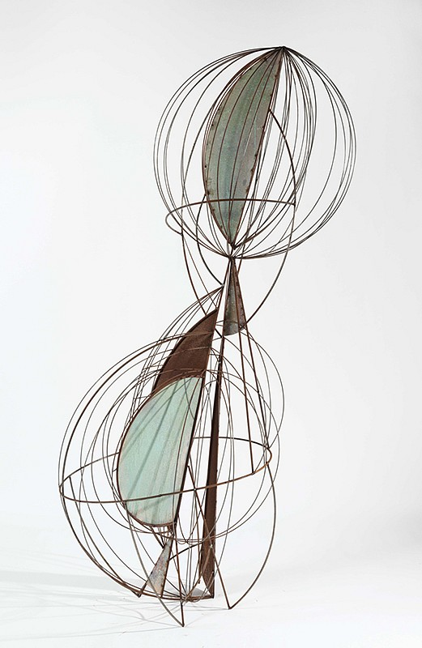
Mike Brown represented by Mike Weiss Gallery in New York
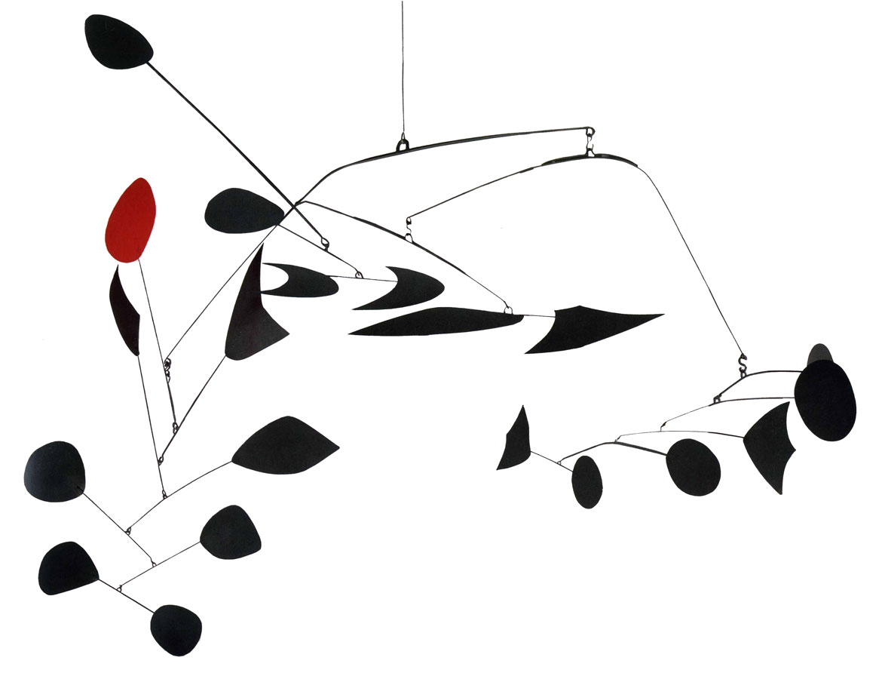
Alexander Calder (1898-1976), whose illustrious career spanned much of the 20th century, is the most acclaimed and influential sculptor of our time. Born in a family of celebrated, though more classically trained artists, Calder utilized his innovative genius to profoundly change the course of modern art. He began by developing a new method of sculpting: by bending and twisting wire, he essentially "drew" three-dimensional figures in space. He is renowned for the invention of the mobile, whose suspended, abstract elements move and balance in changing harmony. Calder also devoted himself to making outdoor sculpture on a grand scale from bolted sheet steel. Today, these stately titans grace public plazas in cities throughout the world.

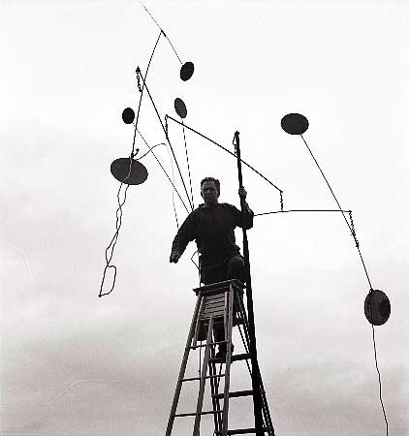

EQ: How do artists create movement in sculpture using different materials?
Objective: SWBAT create a sculpture using hemp and reed where they intersect and cross over in at least 3 different planes focusing on movement, line, and design.
Supplies: Reed Wire Glue (minimal amounts) Tissue Paper

The Task: You are to create a sculpture that is finely constructed thinking of movement, line and design. There needs to be an overlap or intersection of at least 3 different planes. We will be working on how to attach 2 pieces of reed together with hemp and minimal glue. It must be able to hang and be at least 18 inches in one direction. Think about balance, symmetry/non-symmetry and it must not be representational. We will also be using tissue paper in at least two sections.

Grading:
Criteria | Excellent | Good | Average | Needs work | Student total | Teacher total
Size: At least 18 inches in one direction and has at least 3 intersections of planes | 4 | 3 | 2 | 1
Creativity: Movement shown in sculpture and sculpture is non-representational (does not look like something) | 4 | 3 | 2 | 1
Craftsmanship: Construction: Not a lot of glue showing and minimal amount of hemp to keep the reed together and tissue paper has been added in at least 2 places creating movement of the eye | 4 | 3 | 2 | 1
Work ethic/Professionalism | Positive attitude, worked every day, always on task, did not complain about the assignment, on time, and took the assignment further, challenged yourself and showed a high dedication to learning and improvement, asking questions when necessary and using all information sources available, including your classmates.  Cell phones not out | Good attitude, worked every day, mostly on task and used material correctly. The student showed a dedication to learning and improvement and usually asked questions when necessary. Did not complain, cell phone not out other than music time. | Attitude could use some help, student was often off task and used materials and tools incorrectly. The student showed very limited dedication to learning and improvement. The student rarely asked questions and disrupted others, moving about the room and talking loudly. | Attitude was poor. Lack of effort, commitment or participation during the work time which includes disrespect, inappropriate language, misuse with tools in a wasteful or dangerous way, moving throughout the room, disrupting others, excessively talking over the teacher, excessive tardies, complaining…WHINING!
Clean up: cleaned up after yourself | 4 | 3 | 2 | 1
Total points 20 |  |  |  |  | Student total | Teacher total

- How do artists create movement in sculpture using different materials?

- What are the similarities and differences between architecture and sculpture?

